**A Project Report**

**on**

**“Smart Dustbin”**

Submitted in Partial Fulfillment of the Requirement Of

Project-III (BIT206CO)

of

Bachelor of Information Technology

**Submitted to:**



Purbanchal University

Biratnagar, Nepal

**Submitted by:**

Anishu Nachhiring Rai (333692)

Neelisha Shrestha (333700)

Srijana Limbu (333718)

**KIST COLLEGE AND SS**

Kamalpokhari, Kathmandu

March 23, 2023

**Project Supervisor**

**Kiran Khanal**

**CERTIFICATE OF TOPIC APPROVAL SHEET**

It is hereby informed that the topic selected by Anishu Nachhiring Rai, Neelisha Shrestha and Srijana Limbu of the BIT third semester project has been found suitable and as per the credit assigned by Purbanchal University (PU), Biratnagar, Nepal. The Project Committee has approved the following topic and supervisor for the mentioned students. This project has been completed for the prescribed period and the project embodied the result of their investigation conducted during they worked as a full-time students of this institution.

Topic Approved: Smart Dustbin

_____________________ _____________________

Mr. Dipak Khadka Mr. Kiran Khanal

HOD, Department of Information Technology Project Supervisor

Kist College and SS Kist College and SS

**DECLARATION**

We declare that this project report titled Smart Dustbin submitted in partial fulfillment of the Bachelor of Information Technology is a record of original work carried out by us under the supervision of Kiran Khanal and has not formed the basis for the award of any other degree or diploma, in this or any other Institution or University. In keeping with the ethical practice in reporting scientific information, due acknowledgments have been made wherever the findings of others have been cited.

With regards,

Anishu Nachhiring Rai

Neelisha Shrestha

Srijana Limbu

**SUPERVISOR’S APPROVAL**

This is to certify that the major project entitled Smart Dustbin undertaken and demonstrated by Anishu Nachhiring Rai, Neelisha Shrestha and Srijana Limbu has been successfully completed under my supervision as partial fulfillment of the requirements for the degree of Bachelor of information technology, Third Semester under Purbanchal University. Henceforth, approve this project us be awarded the certificate by the concerned authority.

During supervision, I found students hardworking, skilled, and ready to undertake any professional work related to this field in the future.

_____________________

Mr. Kiran Khanal

Project Supervisor

Kist College and SS

Date: 30 April 2023

**CERTIFICATE FROM DEPARTMENT**

Following the Supervisor's Approval and Examiners’ Acceptance, the project entitled “Smart Dustbin" submitted by Anishu Nachhiring Rai, Neelisha Shrestha and Srijana Limbu as a partial fulfillment of the requirements for the degree of Bachelor of information technology, third semester under Purbanchal University, has been officially awarded by this certificate.

I wish the students all the best in their future endeavors.

Kiran Khanal

Project Supervisor

Date: 30 April 2023

# **ACKNOWLEDGEMENT**

We would like to acknowledge all who have encouraged and inspired us directly or indirectly to complete this project. First, we desire to express our deepest sense of gratitude to Purbanchal University for giving us the opportunity to present this report within the scheduled time.

We want to thank Kist College and SS for providing this opportunity by approving our project. We are incredibly grateful to our supervisor Mr. Kiran Khanal, HOD Mr. Dipak Khadka for continuously supporting and guiding us in our project and providing his valuable time to complete our project.

We are fortunate enough to get encouragement and feedback from our teachers and friends. Lastly, many thanks to all the people for their suggestions, feedback, and support which was the most in completing our project successfully.

This project has been a wonderful experience where we have learned and experienced many beneficial things.

With regards

Anishu Nachhiring Rai

Neelisha Shrestha

Srijana Limbu

# **ABSTRACT**

The smart dustbin is a project aimed at improving waste management in urban areas. The system comprises ultrasonic sensor, servo motor and a microcontroller all controlled by the Arduino Uno board. The smart dustbin is designed to automatically detect the fill level and open its lid when someone approaches it, allowing waste to be easily disposed of. After the waste is disposed of. The project's main objective is to reduce the amount of waste in urban areas, improve hygiene and cleanliness, and encourage sustainable waste disposal habits. The project also incorporates programming in C language to control the dustbin's functionality. The smart dustbin using Arduino Uno is a promising solution to the growing problem of waste management, offering a convenient and efficient way to collect and manage waste.

Table of Contents

**ACKNOWLEDGEMENT** vi

**ABSTRACT** vii

**Chapter 1: Introduction** 1

**1.1 Background** 1

**1.2 Significance** 1

**1.3 Objectives** 1

**1.4 Team Structure and Role** 2

**Chapter 2: System Analysis** 3

**2.1 Literature review** 3

**2.2 Working Principle** 3

**Chapter 3: System Design** 4

**3.1** **Required Components** 4

**3.2 Algorithm** 4

**3.3 Block Diagram** 5

**3.4 circuit Diagram** 6

**3.5Gantt Chart** 7

**Chapter 4: System Development and Implementation** 8

**4.1 Programing platform (Tools and technologies used)** 8

4.1.1 Software Specifications 8

4.1.2 Hardware Specifications 8

**Chapter 5: Conclusion** 9

**5.1**  **Conclusion** 9

**5.2 Future Enhancements** 9

**References** 10

# **Chapter 1: Introduction**

## **1.1 Background**

Smart dustbin project is simply designed to turn normal dustbin into advanced one. This project detects the objects or the motion near the dustbin and opens the lid of dustbin.

## **1.2 Significance**

This project is a simple project created to run on microcontroller 8051 using assembly and C programming languages and its main significance is to help in keeping our environment clean and also echo friendly.

## **1.3 Objectives**

* To automates the process of waste collection.
* To help in keeping our environment clean.
* Easy to use and efficient.
  1. **Features**
* Ultrasonic sensors: The robot incorporates ultrasonic sensors that enable it to detect objects in front.
* Servo motor: It is used to open and close the lid of the dustbin automatically, making it easier for users to dispose of their waste.
* Eco-friendly: Many smart dustbins are designed to promote recycling and waste reduction.

## **1.4 Team Structure and Role**

The members assigned with these particular responsibilities:

|  |  |  |  |  |  |
| --- | --- | --- | --- | --- | --- |
| Members | Study and analysis | Designing | Coding  and hardware | debugging | Documentation |
| Neelisha  Shrestha | Neelisha  Shrestha | Neelisha  Shrestha | Neelisha  Shrestha | Neelisha  Shrestha | Neelisha  Shrestha |
| Anishu Nachhiring  Rai | Anishu Nachhiring  Rai | Anishu Nachhiring  Rai | Anishu Nachhiring  Rai | Anishu Nachhiring  Rai | Anishu Nachhiring  Rai |
| Srijana Limbu | Srijana Limbu | Srijana Limbu | Srijana Limbu | Srijana Limbu | Srijana Limbu |

# **Chapter 2: System Analysis**

## **2.1 Literature review**

Smart Dustbin project has the potential to be an effective tool for waste management in urban areas, as it aims to automate the process of waste disposal and optimize waste collection and disposal through the use of sensors and automated lid control. The project's objectives of reducing waste in urban areas, improving hygiene and cleanliness, and encouraging sustainable waste disposal habits are all admirable goals that align with global efforts towards environmental sustainability.

## **2.2 Working Principle**

* It is important to dispose of the trash properly. It is a responsibility with which everyone should comply. In the era of Covid-19, people are trying to innovate everyday life things and make things as contactless as possible. Smart dustbin is one of those innovative ideas.
* The smart dustbin uses an Ultrasonic sensor HC-SR04 to detect objects in front.
* It then sends the signals to Arduino Uno. The Arduino understands the signal and sends a signal to the Servomotor which opens the flap on top of the dustbin.
* Here we have program it to open the race for only 3 seconds after 3 seconds the flap automatically closes. You can change that time just by making minor changes to the code in Arduino IDE.

# **Chapter 3: System Design**

## **3.1 Required Components**

* Arduino Uno
* Ultrasonic Sensor
* Servo Motor
* USB cable
* USB adapter
* Jumper Wires
* Dustbin

## **3.2 Algorithm**

Step 1: Start

Step 2: if Ultrasonic sensor HC-SR04 detect the object in front the led opens automatically with the help of Servo Motor

Step 3: if Ultrasonic sensor HC-SR04 doesn’t detect any object or motion the led closes automatically after 5 seconds or else go to step 4

Step 4: Stop

## **3.3 Block Diagram**

object

Ultra Sonic Sensor

Servo Motor

Dustbin

Arduino Uno

**Fig: Block Diagram of Smart Dustbin**

## **3.4 circuit Diagram**

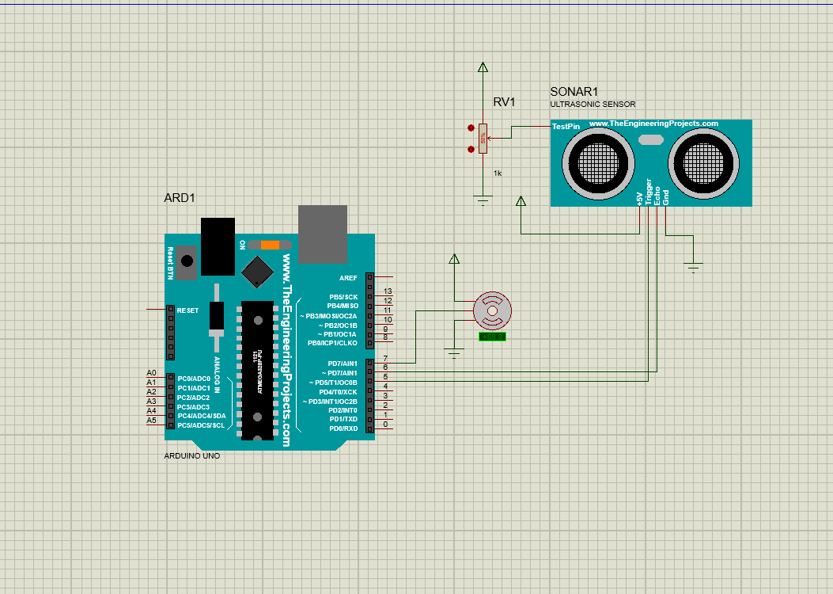

## **3.5 Gantt Chart**

|  |  |  |  |  |  |  |
| --- | --- | --- | --- | --- | --- | --- |
| Task Name | Chaitra(2079) | | | | | |
| **1-5 Days** | **5-10 Days** | **10-15 Days** | **15-20 Days** | **20-25 Days** | **25-30 Days** |
| System Analysis |  |  |  |  |  |  |
| System Design |  |  |  |  |  |  |
| Coding and System  Implementation |  |  |  |  |  |  |
| Debugging and Testing |  |  |  |  |  |  |
| Documentation |  |  |  |  |  |  |

Total time: 1 month

# **Chapter 4: System Development and Implementation**

## 

## **4.1 Programing platform (Tools and technologies used)**

### 4.1.1 Software Specifications

Computer software specification we have used for development:

* Operating System: Windows 10
* Software:Arduino IDE and Proteus
* Programming Language: C

### 4.1.2 Hardware Specifications

Computer hardware specification we have used for development:

* Processor: Ryzen 5
* RAM: 8 GB
* SSD: 256 GB

# **Chapter 5: Conclusion**

## **5.1 Conclusion**

The automatic control of smart dustbin is microcontroller (8051) based project. The smart dustbin using Arduino Uno is an innovative solution to automate waste collection. It is a cost-effective and efficient way to manage waste in homes, offices, and public spaces. By using this system, we can reduce the amount of time and effort required for waste management and improve the overall hygiene and cleanliness of our environment.

## **5.2 Future Enhancements**

* Advanced sensors: Using advanced ultrasonic sensors, would enable to measure the

fill level of the dustbin and trigger notifications when it is full.

* LED lights: LED lights can be used to indicate the status of the dustbin, such as when it is full or when the lid is open.
* Solar-powered operation: To reduce the environmental impact of the smart dustbin project, it could be powered by renewable energy sources such as solar power, which would enable it to operate independently without the need for external power.

# **References**

* <https://www.flyrobo.in/blog/smart-dustbin-arduino>/
* https://www.electronicshub.org/smart-dustbin-using-arduino/